**Brand Name : INTERWOOD**

Kids chairs

# Childrens Classroom Style Chair

**Description :**

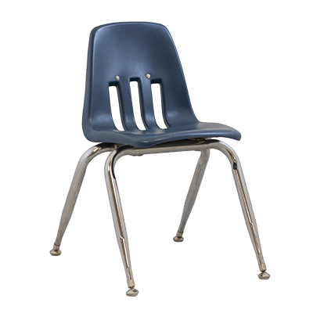**Top Quality ​​Classroom Kids Chair Photos & Videos**  
We provide original unedited photos and videos of ​​study Kids Chair to our customers so that it is more convenient to make decision before placing an order online at chair.com.pk.

**​​** **Classroom Kids Chair Quality Products**  
We provide a “Quality Product” for ​​classroom Kids Chair to our customers. We send to our customer that he/she get a quality product.

**Best Designed Product to Customers**  
We will recommend the best models as per international standards, developed according to the market and customers; we suggest trendy design to the customers according to customers’ needs.

We also deal in bulk quantities order of [**Classroom Chairs**](https://chair.com.pk/product/rosie-kids-chair/) so as in single piece too. We Deliver ​​study Kids Chair in Lahore, Karachi, Faisalabad, Rawalpindi, Peshawar, Islamabad, and All Over Pakistan.

**Rs:1500**